UNION BENEFITS

Many members are not aware that they have THREE benefit programs! Many that your family members are eligible for! (Mortgages, auto insurance, discount shopping, etc.)

HOW DO I REGISTER?

- Use your membership number located on your Access card from FEA.

WHAT IF I DO NOT HAVE A CARD?

- Email steven.borgos@floridaea.org and ask for your membership and local number for AFT registration; confirm your address is correct and request a duplicate card be ordered for you.

WHERE DO I REGISTER?

- With your membership number you can register for all 3 benefit programs. You must use your personal email address for NEA and AFT and Access online.

FEA – Download the mobile app at MyDeals using mobile password 9389-(your membership number). This will give you access to many of your FEA Access benefits. When you receive your card, you will also have a password that will give you access online to additional benefits.

NEA – Register at neamb.com for thousands of benefits and utilize their most
popular “Click and Save” shopping discount program which earns you points to purchase other items in the future from your favorite stores (Old Navy, Home Depot, Macys, etc.).

AFT - Register at aft.org/benefits for hundreds of cost saving benefits including a mortgage program that provides up to $1000 in gift cards after closing/competitive rates; very inexpensive life insurance you can take with you (usually much cheaper than the district’s offering which you usually cannot take when you retire) which provides a free will preparation by a network attorney. Auto club, family coverage for $29 after a $40 gas rebate. ENTIRE HOUSEHOLD. Compare to AAA at $169 are a sample of the many benefits you and your family can take advantage of!

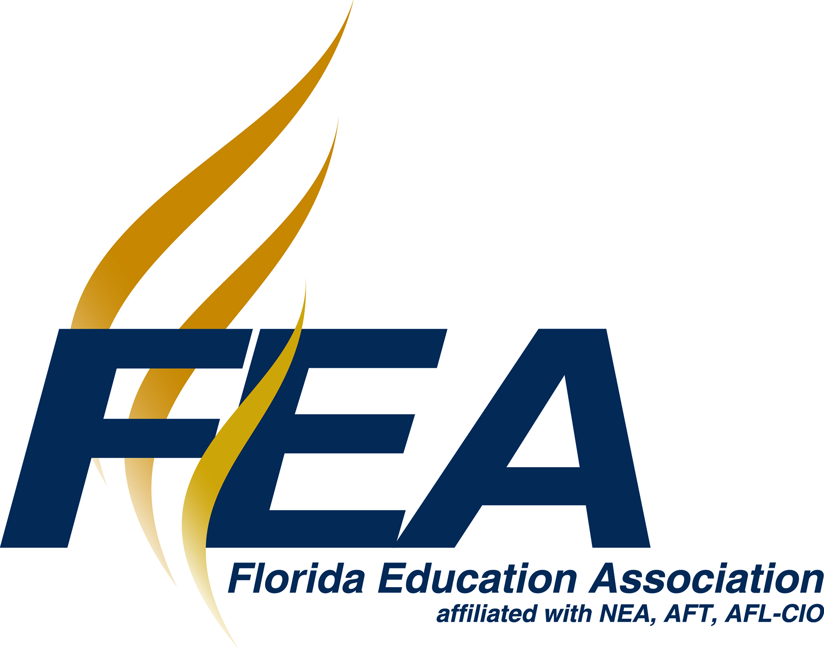
A Union of Professionals AFT PLUS The Benefits of Belonging Great Public Schools for Every Student

